## J2-Health

Scoping start date: Mar 28, 2024

Implementation Completed Date (Go live date):

MSA Signature Date: Mar 26, 2024

GTM POC: Skoro

ERP: QBO

Tax Integration: Other

Website: <https://j2health.com/>

### 

### Key people at Merchant

### Business Strategy and Primary Contact: [Ananth Raghavan](https://www.linkedin.com/in/ananth-raghavan-b55809162/) <ananth@j2health.com>

### Head of Operations & GTM: [Ava Woychuk-Mlinac](https://www.linkedin.com/in/avaw-m/) <ava@j2health.com>

* + More Senior than Ananth, not sure if direct manager

### Company summary

Healthcare provider networks activation software  
  
AM Notes

Also a Primary.vc portfolio company

Seemingly lots of nuances

### Billing model

* For monthly invoicing, they currently bill all customers on the 1st of every month. So, if a contract is signed in the middle of a month then the first and last months are prorated based on when the bill is sent. For ex: if a contract is signed on July 15, then the first bill on August 1st accounts for July 15-August 31, and then the last bill of the year long term is billed at half to account for the remainder of the annual cost.
* They also have a tiered model based on how many states the customer is including, as specified within the contracts.

### Contract Processing Steps

1. Steps to process or specifics processing things merchant has requested that may differ from contract (e.g. always back-date invoice date to final day of the month)
2. Billing terms by state are unit tier pricing with a dependency for the variable input  
     
   **Example:  
     
   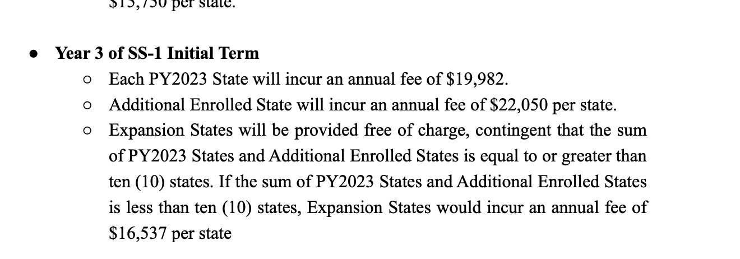**PY State Costs = X * 19,982  
   Addt’l States = Y * 22,050  
   Expansion States = if X+Y > 10 then $0 * Z  
    = if X+Y < 10 then $16,537 * Z  
     
   **PLEASE Note to Calculate Expansion States in order to properly assess Expansion State Pricing as part of events based billing rule**
   1. Note down the calculation in the feedback column (Azmat sends this to the Merchant).
3. Escalators are usually mentioned for multi-year contracts
   1. Create a separate revenue schedule for each year and calculate the price based on the previous year.
   2. Example:
      1. Escalator: 5% each year
      2. Year 1: $600K
      3. Year 2: $630K (+5% of $600K)
      4. Year 3: $661.5 (+5% of $630K)
4. **Invoices appear to be billed monthly** (pro-rate out annual figures for 12 invoices per month)
   1. J2 will send us prorated state quantity for first and last months for applicable states
5. If a contract starts mid-period, prorate the first and last invoice.
   1. For a contract starting on July 20 and billed monthly:
      1. Invoice Date: August 1
      2. Billing Term 1: July 20 to July 31
      3. Billing Term 2: August 1 to August 31
      4. Billing Term 13: July 1 to July 19 (of the next year if 12 month term)
6. Contracts with multiple line items or complex billing schedules should be broken down into detailed billing terms
   1. Example: Contracts with separate billing for different services (e.g., adequacy and marketability) should have clear line items on invoices.
7. Item Name needs to match previous invoices
8. Use J2 software as integration item across the board for all BTs
9. The language in the **Payment Terms** section of contracts that states “Customer shall remit [Frequency] usage charge to the Vendor” refers to the billing cadence.
   1. No usage BTs are required for this merchant
10. Default Frequency: Monthly
11. Default Net [Check with Azmat]
12. Default Customer Info [Check with Azmat]
13. Default Term: 3 years
    1. Check previously sent invoices to check how many years are left for amendments
14. If the customer has already churned, marked as processed with no BTs. [Attach the list here]
15. **Insert**
16. Please send slack bot notification for first invoice after contract processing is complete.7

### Events Processing (if necessary)

* Any important information on events billing

### Customer Information

* Any important information on specifics customers of this merchant
  + Special memo’s certain invoices require
  + Invoice changes due to merchant/customer relationship

### Feature Requests

* FR 1
  + What is it
  + Why it's important
  + Urgency

### Rewatch Calls

* Rewatch by dates